Alternate Exterior Angles
# Source: AI Source: Provided by: [Data Path: Persons Table -> ID Column: 1, Name_En Column: Motasem Essam] -> From: [ChatGPT] on [7/25/2026]
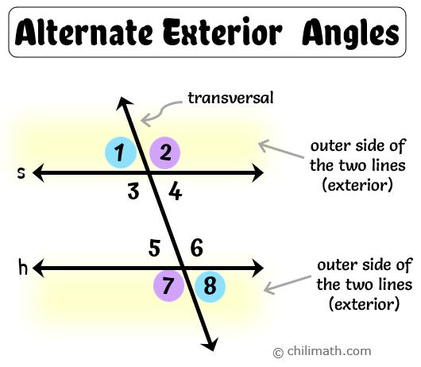
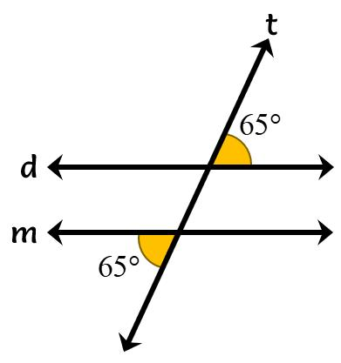
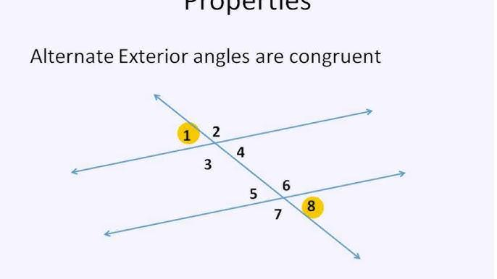
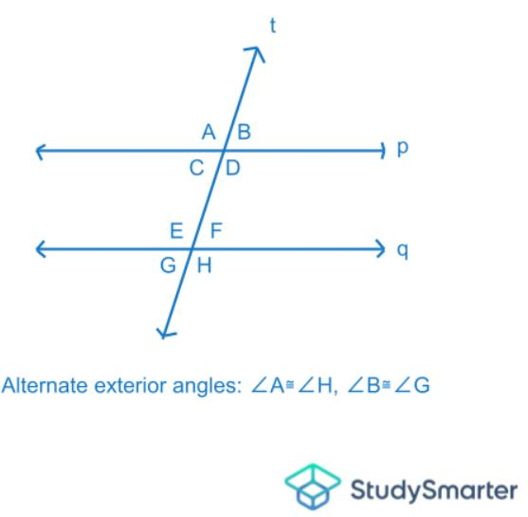
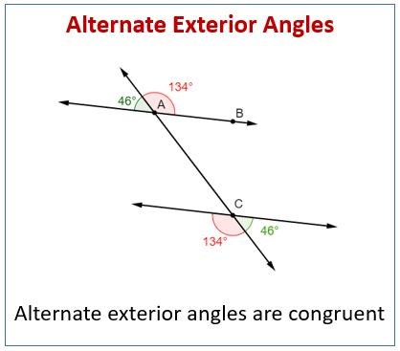
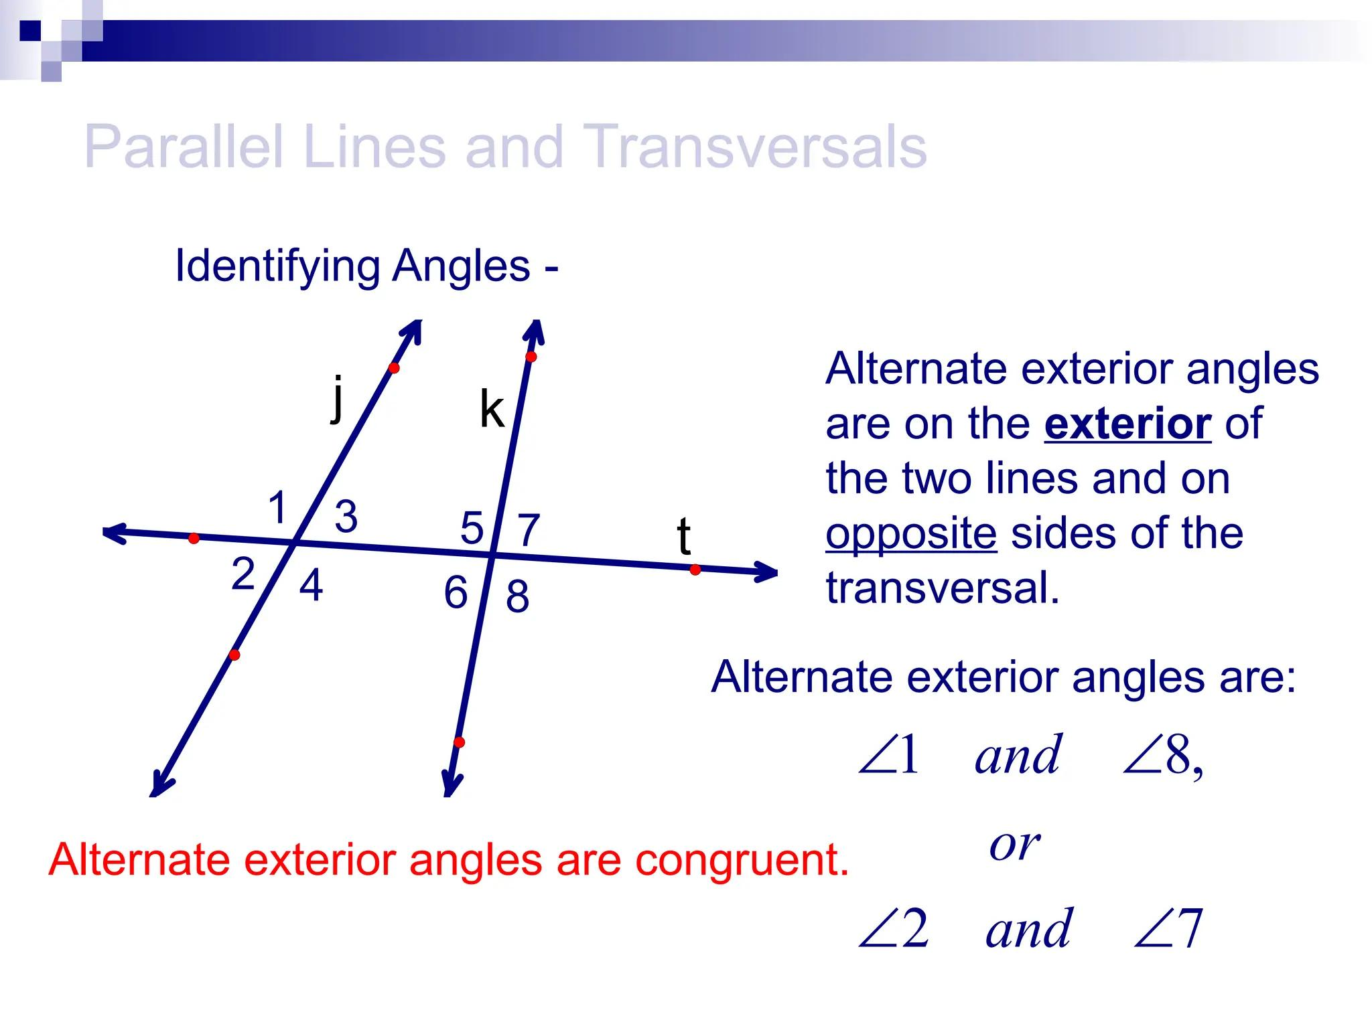

Definition
# Source: AI Source: Provided by: [Data Path: Persons Table -> ID Column: 1, Name_En Column: Motasem Essam] -> From: [ChatGPT] on [7/25/2026]
Alternate Exterior Angles are a pair of angles that lie outside two lines and on opposite sides of a transversal.
When the two lines are parallel, alternate exterior angles are equal in measure (congruent).

Characteristics
# Source: AI Source: Provided by: [Data Path: Persons Table -> ID Column: 1, Name_En Column: Motasem Essam] -> From: [ChatGPT] on [7/25/2026]
Alternate exterior angles:
- Are formed when a transversal intersects two lines.
- Lie outside the two lines (exterior region).
- Are on opposite sides of the transversal.
- Are located at different intersections.
- Are congruent only if the two lines are parallel.

Illustration
# Source: AI Source: Provided by: [Data Path: Persons Table -> ID Column: 1, Name_En Column: Motasem Essam] -> From: [ChatGPT] on [7/25/2026]
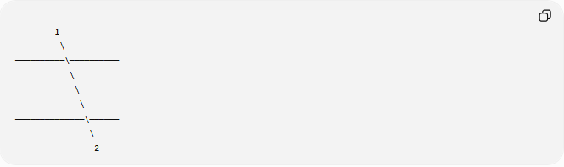
1
\
──────────\──────────
\
\
\
──────────────\──────
\
2
Angles 1 and 2 are:
- Outside the two lines.
- On opposite sides of the transversal.
Therefore, they are alternate exterior angles.

Alternate Exterior Angles Theorem

Theorem
# Source: AI Source: Provided by: [Data Path: Persons Table -> ID Column: 1, Name_En Column: Motasem Essam] -> From: [ChatGPT] on [7/25/2026]
If two parallel lines are cut by a transversal, then each pair of alternate exterior angles is congruent.
If:
$$l_{1}∥l_{2}$$
then:
$$∠1≅∠2$$
or
$$m∠1=m∠2$$

Converse Theorem
# Source: AI Source: Provided by: [Data Path: Persons Table -> ID Column: 1, Name_En Column: Motasem Essam] -> From: [ChatGPT] on [7/25/2026]
If two lines are cut by a transversal and a pair of alternate exterior angles are congruent,
$$m∠1=m∠2$$
then the two lines are parallel.

Mathematical Representation
# Source: AI Source: Provided by: [Data Path: Persons Table -> ID Column: 1, Name_En Column: Motasem Essam] -> From: [ChatGPT] on [7/25/2026]
For parallel lines:
$$m∠A=m∠B$$
or
$$θ_{1}=θ_{2}$$

Example 1
# Source: AI Source: Provided by: [Data Path: Persons Table -> ID Column: 1, Name_En Column: Motasem Essam] -> From: [ChatGPT] on [7/25/2026]
Given:
$$m∠1={45}^{∘}$$
Find:
$$m∠2$$
Since alternate exterior angles are equal:
$$m∠2={45}^{∘}$$

Example 2
# Source: AI Source: Provided by: [Data Path: Persons Table -> ID Column: 1, Name_En Column: Motasem Essam] -> From: [ChatGPT] on [7/25/2026]
Given:
$$m∠A={\left(2x+15\right)}^{∘}$$
$$m∠B={\left(5x-45\right)}^{∘}$$
Because they are alternate exterior angles:
$$2x+15=5x-45$$
Solve:
$$60=3x$$
$$x=20$$
Angle measure:
$$2\left(20\right)+15={55}^{∘}$$
Therefore:
$$m∠A=m∠B={55}^{∘}$$

Position of Alternate Exterior Angles
# Source: AI Source: Provided by: [Data Path: Persons Table -> ID Column: 1, Name_En Column: Motasem Essam] -> From: [ChatGPT] on [7/25/2026]
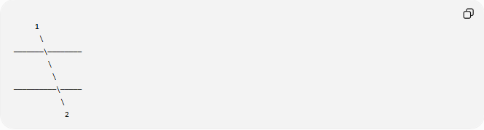
1
\
───────\────────
\
\
──────────\─────
\
2
The two angles:
- Lie outside the parallel lines.
- Are on opposite sides of the transversal.

Relationship with Other Angles
# Source: AI Source: Provided by: [Data Path: Persons Table -> ID Column: 1, Name_En Column: Motasem Essam] -> From: [ChatGPT] on [7/25/2026]
When two parallel lines are cut by a transversal:
- Corresponding angles are equal.
- Alternate interior angles are equal.
- Alternate exterior angles are equal.
- Same-side interior angles are supplementary.

Real-World Examples
# Source: AI Source: Provided by: [Data Path: Persons Table -> ID Column: 1, Name_En Column: Motasem Essam] -> From: [ChatGPT] on [7/25/2026]
Alternate exterior angles appear in:
- Railroad tracks crossed by a road.
- Parallel bridges with crossing beams.
- Building frames.
- Fence structures.
- Engineering blueprints.
- Architectural drawings.

Applications
# Source: AI Source: Provided by: [Data Path: Persons Table -> ID Column: 1, Name_En Column: Motasem Essam] -> From: [ChatGPT] on [7/25/2026]
Alternate exterior angles are used in:
- Plane Geometry
- Coordinate Geometry
- Parallel Line Geometry
- Trigonometry
- Engineering
- Architecture
- Construction
- Surveying
- CAD (Computer-Aided Design)
- Technical Drawing

Advantages
# Source: AI Source: Provided by: [Data Path: Persons Table -> ID Column: 1, Name_En Column: Motasem Essam] -> From: [ChatGPT] on [7/25/2026]
Studying alternate exterior angles helps to:
- Determine unknown angle measures.
- Prove lines are parallel.
- Solve geometric proofs.
- Analyze transversal relationships.
- Understand parallel-line properties.

Limitations
# Source: AI Source: Provided by: [Data Path: Persons Table -> ID Column: 1, Name_En Column: Motasem Essam] -> From: [ChatGPT] on [7/25/2026]
Alternate exterior angles are equal only when:
- Two lines are parallel.
- A transversal intersects both lines.
If the lines are not parallel, alternate exterior angles are not necessarily equal.

Comparison with Other Angle Relationships
# Source: AI Source: Provided by: [Data Path: Persons Table -> ID Column: 1, Name_En Column: Motasem Essam] -> From: [ChatGPT] on [7/25/2026]
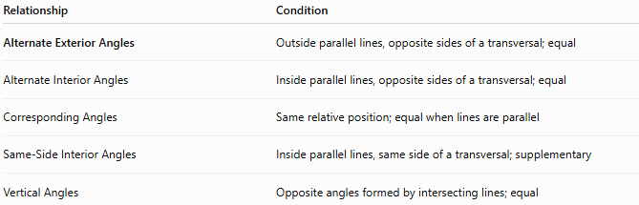
Relationship | Condition
Alternate Exterior Angles | Outside parallel lines, opposite sides of a transversal; equal
Alternate Interior Angles | Inside parallel lines, opposite sides of a transversal; equal
Corresponding Angles | Same relative position; equal when lines are parallel
Same-Side Interior Angles | Inside parallel lines, same side of a transversal; supplementary
Vertical Angles | Opposite angles formed by intersecting lines; equal

Key Points
# Source: AI Source: Provided by: [Data Path: Persons Table -> ID Column: 1, Name_En Column: Motasem Essam] -> From: [ChatGPT] on [7/25/2026]
- Alternate Exterior Angles lie:
  - Outside the two lines.
  - On opposite sides of the transversal.
- If the lines are parallel:
$$m∠1=m∠2$$
- Their converse theorem can be used to prove that two lines are parallel.

Conclusion
# Source: AI Source: Provided by: [Data Path: Persons Table -> ID Column: 1, Name_En Column: Motasem Essam] -> From: [ChatGPT] on [7/25/2026]
Alternate Exterior Angles are pairs of angles located outside two lines and on opposite sides of a transversal. When the lines are parallel, these angles are always congruent (equal in measure). This important geometric relationship is widely applied in plane geometry, coordinate geometry, trigonometry, engineering, architecture, construction, surveying, CAD, technical drawing, and computer graphics to determine unknown angles, analyze transversal configurations, and prove line parallelism.

